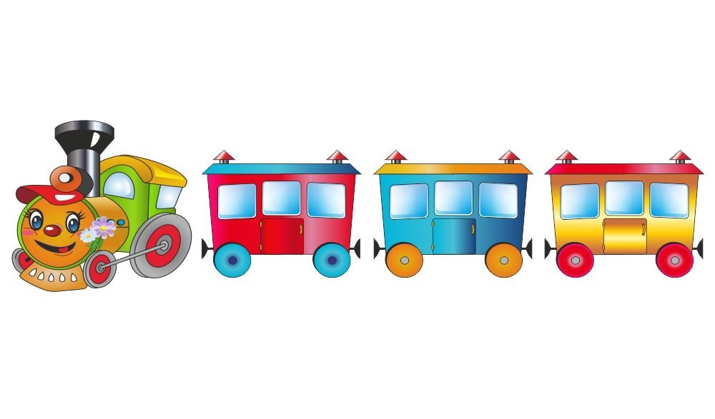  **1**

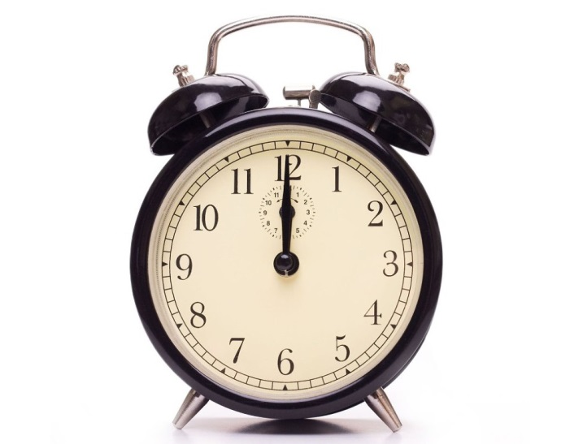 **2**

**3**

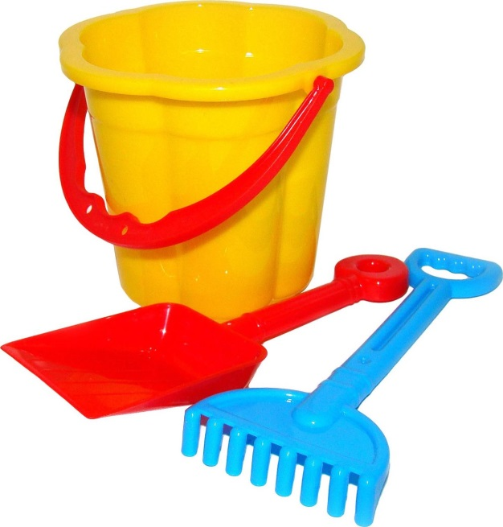 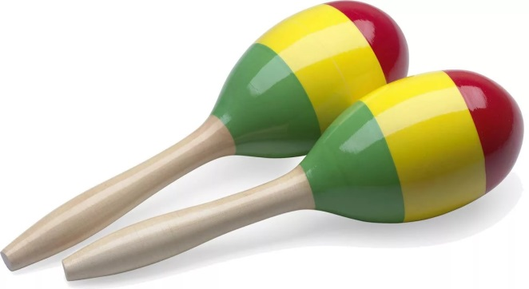

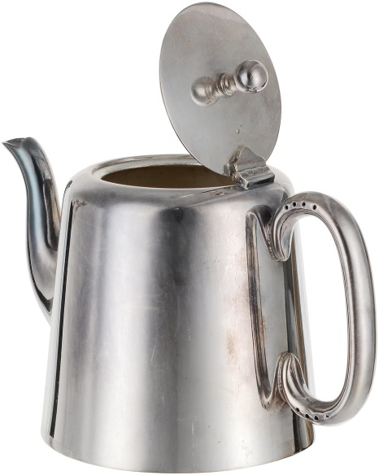 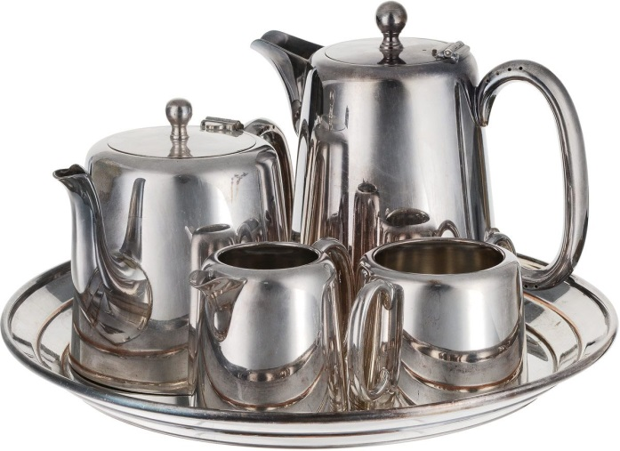

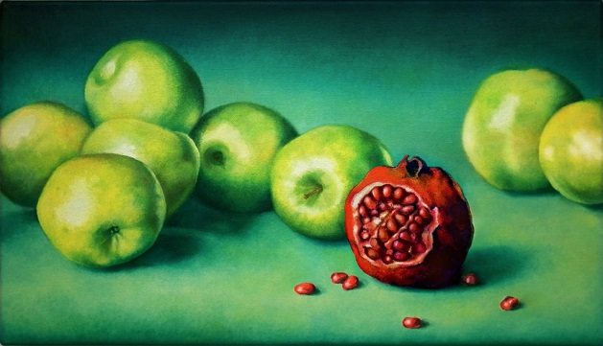 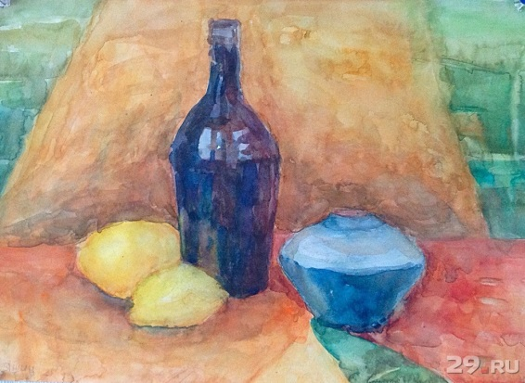

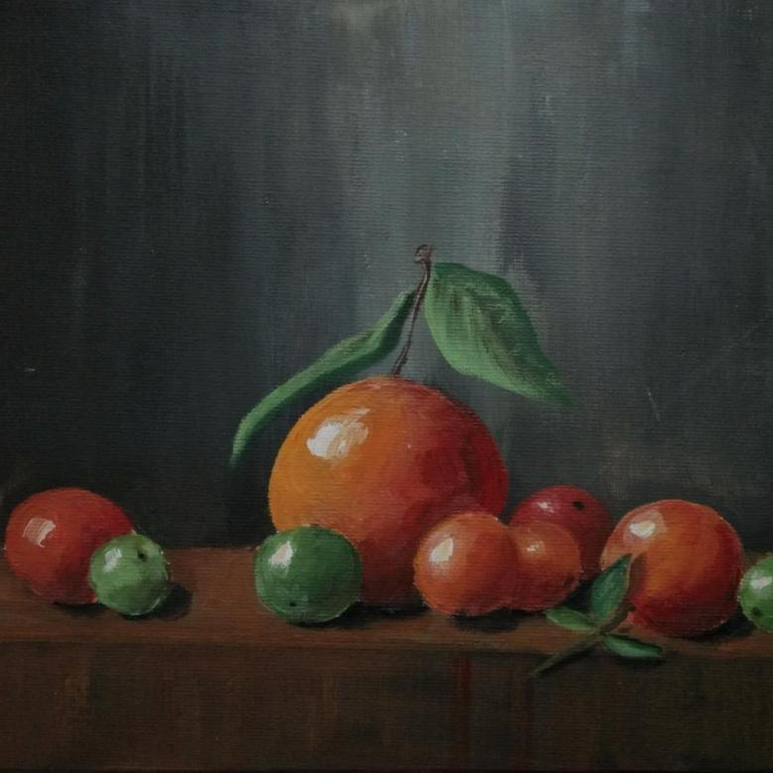 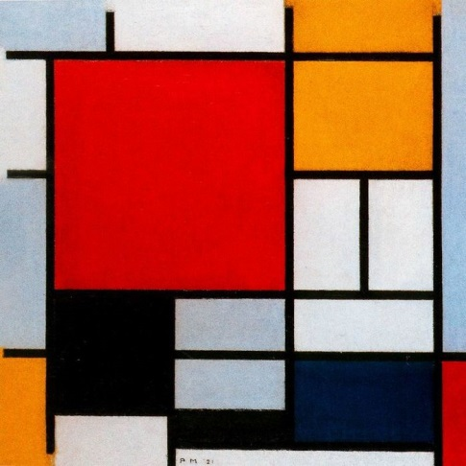

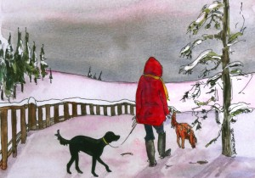 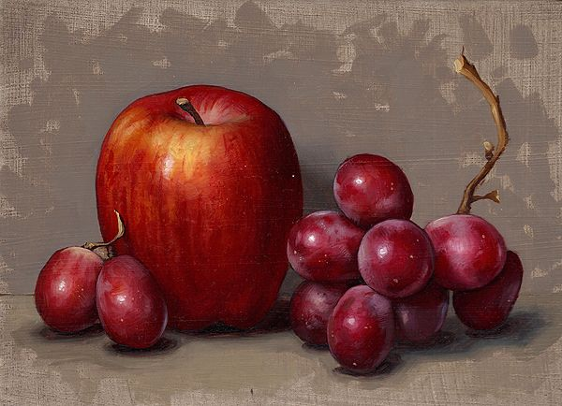

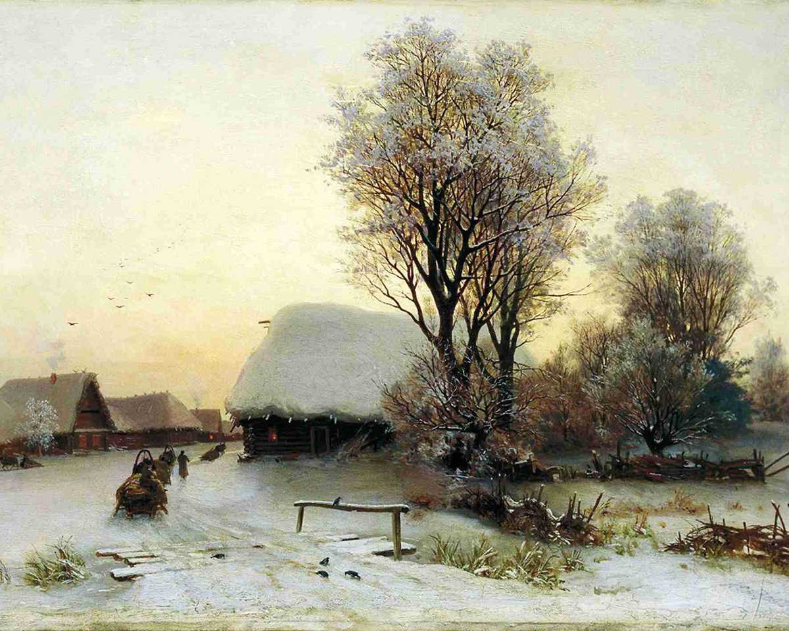

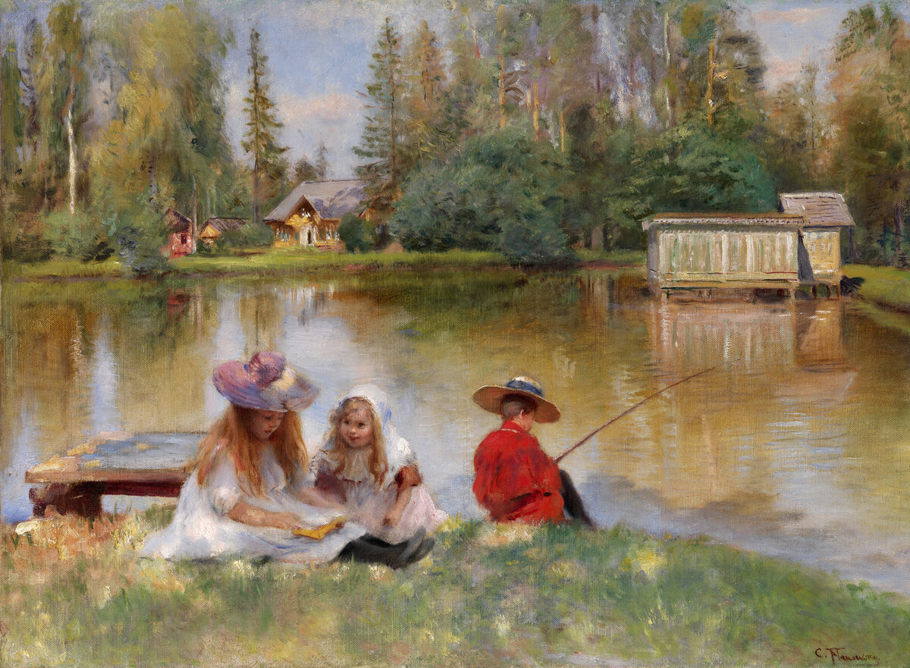

Протокол соревнований «Секреты удачной картины»

|  |  |  |
| --- | --- | --- |
| № задания | **Красные** | **Синие** |
| 1 |  |  |
| 2 |  |  |
| 3 |  |  |
| 4 |  |  |
| 5 |  |  |
| 6 |  |  |
| 7 |  |  |
| 8 |  |  |
| 9 |  |  |
| 10 |  |  |
| 11 |  |  |
| **Итог** |  |  |

Жюри: ______________________________________

______________________________________

_______________________________________________________________________________________________________________________________________________________________________________________________________________________________________________________________________________________________________________________________________________________________________________________________________________________________________________________________________________________________________________________________________________________________________________________________________________________________________________________________________________________________________________________________________________________________________________________________________________________________________________________________________________________________________



1 2 3 4 5 6