Внеклассное мероприятие по английскому языку
Ecological problems of two countries and two lakes: Superior and Baikal.
Ways to solve these problems

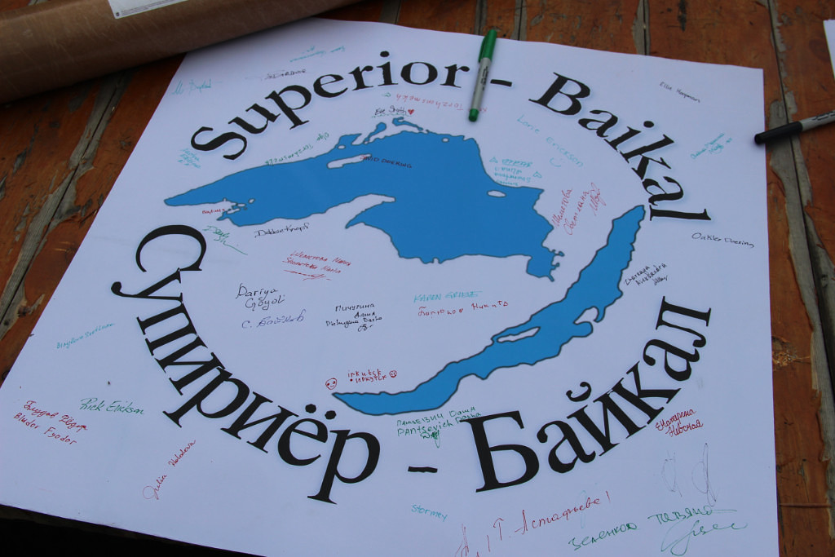

Внеклассное мероприятие по английскому языку
«Ecological problems of two countries and two lakes: Superior and Baikal. Ways to solve these problems»
«Экологические проблемы двух стран, двух озер и пути решения этих проблем» в рамках международного социального проекта «Два озера-Two Lakes», ежегодно проводимого в МБОУ гимназии №44 г. Иркутска для 8-11 классов.
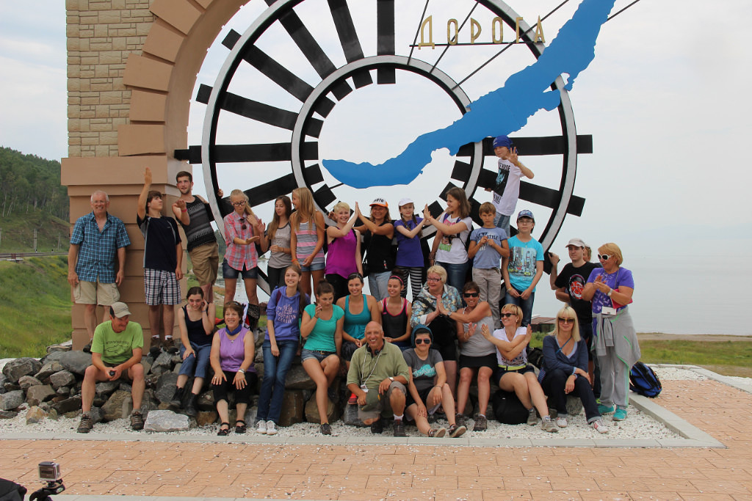
Руководители проекта: Калашникова Ю.А., Астафьева Т.В., учителя английского языка МБОУ Гимназия №44 г. Иркутск. Участники проекта: учащиеся 10 «А», «Б» классов
Аннотация
Тему данного проекта мы выбрала не случайно. Каждый год в нашей гимназии проводятся воспитательные мероприятия на английском языке в рамках международного проекта «Два озера». В 2017 г мы работали над темой: «Экологические проблемы озер Америки и России». Для исследования в рамках проекта мы выбрали озеро Superior, расположенное на границе Канады и США, и озеро Байкал, которое находится в Иркутской области. Данный проект рассчитан на плодотворную работу учащихся под руководством учителя. Проект предназначен для учащихся 8-11 классов.
Задача учащихся использовать материалы дополнительных источников, информацию по результатам общения по скайпу с друзьями из Америки для подготовки презентации об экологических проблемах озер и способах их решения.
Работая над этой темой, учащиеся совершенствуют навыки аудирования, чтения, диалогической и монологической устной речи, грамматики, письма. Учащиеся самостоятельно изучают английский язык доступными им способами (через Интернет, с помощью обучающих справочников и живого общения с носителями языка), развивают специальные учебные умения (пользоваться словарями, интерпретировать информацию текста и др.), умение пользоваться современными информационными технологиями.
Проект поможет учащимся закрепить лексику по теме « Экология», систематизировать знания, расширить их кругозор.
Участники: учащиеся 10 класса
Предметная область: английский язык
Проблема: противоречие между объективной потребностью прогресса цивилизации и его негативным влиянием на окружающий мир.
Идея проекта: поиск путей и способов преодоления существующего противоречия.
Цель проекта: выявить экологические проблемы двух озер (Superior, Baikal) и на основе установления причинно-следственных связей разработать способы решения (или минимизации) выявленных проблем.
- Формирование и развитие коммуникативных навыков, лингвистической одаренности.
- Формирование у учащихся понимания глобальной проблемы человечества, связанной с защитой и сохранением окружающей среды и желание проявить заботу об окружающем мире;
- Формирование у школьников экологического сознания.
- Воспитание культуры общения с природой, умение охранять её от воздействия человека;
- Создать условия для раскрытия творческих способностей у учащихся.
Задачи:
1.Изучить существующие экологические проблемы озер (Superior, Baikal) и способы их решения;
2. Найти и изучить соответствующие материалы о наличии экологических проблем и их влиянии на здоровье людей и способы их решения;
3.Выделить (на основе прогнозирования возможных последствий реализации предлагаемых решений проблемы) потенциальные проблемы, с которыми придется столкнуться двум странам в отношении спасения чистой экологии двух озер (Superior, Baikal).
Методы работы над проектом:
Используются исследовательские методы: определение проблемы, вытекающих из нее задач исследования, выдвижение гипотезы их решения, обсуждение методов исследования, оформление конечных результатов, анализ полученных данных, подведение итогов, корректировка, выводы.
Сроки выполнения проекта:
Проект рассчитан на 2 месяца (октябрь, ноябрь)
Актуальность выбранной темы:
Проблемы экологии сегодня становятся не просто главными в развитии общества, но и весьма острыми для самого выживания человека. И это не удивительно. В последнее время в Российской Федерации к экологическим проблемам оказывается повышенное внимание. Как известно, 2017 год был Годом охраны окружающей среды. Экологическое образование официально признано сегодня как одно из приоритетных направлений совершенствования деятельности образовательных систем. Экологическое воспитание и образование детей - чрезвычайно важная задача современного общества. Обострение экологической проблемы в стране и в мире диктует необходимость интенсивной просветительской работы по формированию у детей экологического сознания, культуры природопользования.
Только экологическое мировоззрение и экологическая культура современных людей могут вывести планету и человечество из того состояния, в котором оно находится сейчас.
Ожидаемые результаты работы над проектом:
-формирование экологического мышления учащихся;
-появление творческого потенциала и языковой компетенции у учащихся;
-повышения интереса к изучению английского языка и его практического применения.
Обоснование необходимости проекта:
Экологическое обучение и воспитание должно проводится на каждом уроке, т.к. проблемы экологии являются одними из самых важных в современном мире. На уроке английского языка мы каждый год возвращаюсь к этой важной теме. Учителя не могут оставаться в стороне от экологического загрязнения окружающей среды и должны нести моральную ответственность за понимание учащимися сути экологических проблем. Это отличная тема для изучения английского языка. Во-первых, проблемы загрязнения окружающей среды являются ценным источником учебной информации. Изучая эту тему, мы работаем над лексикой про животных, растения, деятельность людей, развитие промышленности, экологические проблемы воды, воздуха, почвы… Т.е. имеем дело с очень большим лексическим запасом слов. Эта тема может стать полезной для интеграции интересного содержания в процесс обучения иностранному языку.
Эта тема предоставляет большие возможности для организации работы над учебными проектами и другими видами формами учебной деятельности, которые требуют интеграции всех речевых умений. В процессе работы, наряду с базовыми умениями и навыками, учитель формирует у школьников и такие более сложные языковые умения, как умение критически мыслить, умение принимать решение в группе, умение избирательно читать предлагаемые материалы.Работа над проектом по экологии должна дать детям интересный, полезный и увлекательный опыт.
План работы:
ПРЕДВАРИТЕЛЬНЫЙ ЭТАП

- Нами была проведена видеотрансляция между учениками Америки, проживающими на озере Superior, и учениками города Иркутска, гимназии №44, которые представляли озеро Байкал и его экологические проблемы.
- Учениками гимназии №44 были найдены и изучены интернет источники на тему экологических проблем озера Байкал и озера Superior .

ОРГАНИЗАЦИОННЫЙ ЭТАП

Раскрытие общей цели занятия и плана его проведения.
Ведущий: Dear friends! Welcome to our Ecological Conference!
Let me introduce myself… Today our pressure groups have a meeting here. We have participants from two lakes Superior, Baikal and their leaders ////////.
Ведущий: Now I want to ask you: What is ecology for you? (Give only one word)
Ведущий:“Water, water everywhere, not any drop to drink,” said the sailor from Coleridge's poem describing to a friend how awful it was to be without drinking water on a ship in the middle of the ocean. It is strange to think that the water around his ship was probably quite safe to drink. It was salty - but not polluted. The sea waters today are much more dangerous. There is no ocean or sea which is not used as a dump. Many rivers and lakes are poisoned too. Fish and reptiles can't live in them. There is not enough oxygen in the water. In such places all the birds leave their habitats and many plants die. If people drink this water they can die too.
Ведущий: How do you think: What is the aim of our conference? What are we going to speak about?
Ведущий: Yes, the aim of our conference is to discuss the water pollution and ecological problems of two lakes (Superior, Baikal) Also we should find the possible ways of their decision. So you have the plan of our work today…
Приложение №1 План работы конференции

ОСНОВНОЙ ЭТАП

Конкурс 1 «Давайте познакомимся».«Let's get acquainted»
Команды представляют себя (название команды, девиз, приветствие должны отражать тематику мероприятия).
Одна команда представляет озеро Superior, вторая озеро Байкал
Конкурс 2 «Экологическая зарядка – два озера»
«Ecological brainstorm – two lakes»
Викторина Quiz
Викторина проводится для обеих команд, ученики должны показать знания основных фактов, связанных с озерами. Независимо какое озеро представляет команда, отвечать на вопросы могут члены и той и другой команды.
Ведущий: It's time to find out how much you know about the lakes!
Приложение № 2 Вопросы викторины
Конкурс 3 «Презентационный. ЭКОЛОГИЧЕСКИЕ ПРОБЛЕМЫ ОЗЕРА»
Competition of presentations. ENVIRONMENTAL PROBLEMS OF THE LAKE
Каждая команда представляет свою презентацию и доклад на английском языке на тему «ENVIRONMENTAL PROBLEMS OF THE LAKE». На защиту проектов приглашаются учащиеся других классов. Учащиеся показывают перед учащимися младших классов результат своего труда над проектом (презентацию или фильм). Учащиеся 11-го класса приглашаются в жюри. Учитель координирует работу учащихся, стимулирует их деятельность.
Ведущий: Now let’s listen to our teams.
Приложение №3 Материал по озерам (Superior, Baikal)
Конкурс 4 Check your knowledge about the topic
Каждая команда получает пустую карточку, куда участники, соревнующихся команд должны занести необходимую информацию об озерах.
Ведущий: It's time to check how well our experts know the basic facts associated with the lakes Superior and Baikal !
Приложение № 4 пустые карточки для команд
Конкурс 5 Групповая работа «ПУТИ РЕШЕНИЯ ЭКОЛОГИЧЕСКИХ ПРЛОБЛЕМ»
Group work «WAYS OF SOLVING ENVIRONMENTAL PROBLEMS»
Команды на основе презентаций и докладов должны выявить экологические проблемы озёр и представить пути решения экологических проблем. Команда «Superior» предлагает пути решения экологических проблем озера Байкал и наоборот. Командам выдается лист формы (А 3) на котором участники не только изображают общие экологические проблемы, но и находят пути их решения.
Ведущий: Now let’s work in groups. Share your opinions about ecological problems. Try to find the possible ways of the decision of these ecological problems. Give your suggestions about your future work on ecological problems.
Приложение № 5 Материал по экологическим проблемам двух озер (Superior, Baikal)
Оценка результатов. (Групповой самоанализ и самооценка).
Учащиеся участвуют в групповом самоанализе и самооценке проектов.
Рефлексионный.
Подведение итогов работы, обсуждение, высказывание пожеланий. Оценка работы и активности учащихся.
Учащиеся участвуют в коллективной оценке результатов проекта. Результаты каждой команды высчитываются по таблице алгоритма оценивания проекта
Ведущий: DEARPARTICEPANTSOFTHECONFERENCE!
GIVE YOUR OPINION ABOUT OUR MEETING, PLEASE.
WE WILL BE VERY THANKFULL TO YOU!
WHAT IS YOUR MOOD AND FEELINGS ABOUT OUR CONFERENCE?
PLEASE DRAW IT (OR MARK IT):
WHAT IS YOUR MAIN IDEA AND OPINION ABOUT OUR CONFERFNCE ?
Приложение №6 Критерии оценивания
Заключение.
В заключение хочется отметить, что работа над данным проектом способствует удовлетворению и развитию познавательных потребностей учащихся. Собранным материалом учитель может в дальнейшем пользоваться на уроках иностранного языка. В результате работы над проектом удастся создать для каждого члена группы личностно-ориентированную ситуацию и условия для выбора партнера и предпочтительной деятельности, тем самым, индивидуализируя и дифференцируя процесс обучения и воспитания. Данный проект помогает делать учебный процесс более увлекательным и интересным, раскрывать значение получаемых на уроках знаний и их практическое применение в жизни.

Приложение №1
План работы конференции
«Ecological problems of two countries and two lakes: Superior and Baikal. Ways to solve these problems»

Конкурс 1 «Давайте познакомимся»
«Let's get acquainted»
Конкурс 2 «Экологическая зарядка – два озера»
«Ecological brainstorm – two lakes»
Викторина Quiz
Конкурс 3 «Презентационный. ЭКОЛОГИЧЕСКИЕ ПРОБЛЕМЫ ОЗЕРА»
«Competition of presentations. ENVIRONMENTAL PROBLEMS OF THE LAKE»
Конкурс 4 Check your knowledge about the topic
Конкурс 5 Групповая работа «ПУТИ РЕШЕНИЯ ЭКОЛОГИЧЕСКИХ ПРЛОБЛЕМ»
Group work «WAYS OF SOLVING ENVIRONMENTAL PROBLEMS»
Оценка результатов (Групповой самоанализ и самооценка).
Рефлексионный
DEARPARTICEPANTSOFTHECONFERENCE!
GIVE YOUR OPINION ABOUT OUR MEETING, PLEASE.
WE WILL BE VERY THANKFULL TO YOU!
WHAT IS YOUR MOOD AND FEELINGS ABOUT OUR CONFERENCE?
PLEASE DRAW IT (OR MARK IT):
WHAT IS YOUR MAIN IDEA AND OPINION ABOUT OUR CONFERFNCE ?
Приложение № 2 Вопросы викторины

What is the surface area of Lake Baikal?
It is 31,500 square kilometers and equal to the area of such countries as Belgium, Netherlands or Denmark. By its surface area Baikal ranks eighth among world's largest lakes.

What is the water mass volume of Baikal ?
The total water volume on the Earth is about 1406 mln. cubic kilometers. Of them lakes and rivers contain 0.231 mln. cubic km. The volume of baikalian water mass is about 23.000 cubic kilometers. It is greater than the water volume contained in all five taken together Great Lakes in North America ( Superior, Michigan, Huron, Erei, Ontario), in the Baltic, by 23 times greater than in Ladoga Lake. Lake Baikal contains one-fifth of the world's surface water resources (except ice of Antarctica, Green land and other glaciers), and four-fifth of fresh waters of Russia.

What does the word Baikal mean?
The word Baikal is derived from the Turkish Bai-Kul, which means "a rich lake" (compare: Issyk-Kul - a warm lake, Kara-kul - a black lake). Some authors believe this word to come from the Mongolian Baigal (rich fire) or Baigal-Dalai (large sea).

What is the greatest and average depth in Baikal ?
Baikal is the deepest lake on the Earth. Its average depth is about 730 m. For the first time it was exactly calculated by G. Yu. Vereshagin in the 30's. The deepest known depth of Baikal (and lakes of the world) is 1637 m.

Where does the Baikal coastline lie?
The coastline is 456 m above ocean level. The coastline is a boundary between land and water surfaces. On the map it is drawn along the line of an average little water level. The real boundary between land and lake - the edge line - is constantly changing due to water fluctuations.

How has the Baikal level changed after the construction of the Irkutsk hydropower station dam?
The level has risen by 1 m. The surface area of the lake has increased by 500 square km. It has resulted in serious ecological problems.

How many tributaries does Baikal have ?
336 rivers and rivulets (constant watercourse).

How old is Baikal?
It is 20-25 mln. years old. But a modern shape Baikal acquired relatively recently, may be some million years ago.

Where are maximum depths located in Baikal?
By the eastern shore of the Olkhon Island between Izhimey and Khara-Khushun capes 8-12 km to the east from the shore (depth 1637). In the southern trough of Baikal the maximum depth (1432 m) is located between the rivers Pereemnaya and Mishikha, in the northern trough - 890 m between the Elokhin and Pokoiniki capes.

Are there submerged ranges in Baikal?
Most expressive is the Akademichesky Range, stretching from the Olkhon Island towards the Ushkany Islands. Its stretch is about 100 km, maximum height over the bottom of Baikal is about 1848 m.

Who controls the Baikal ecosystem state?

Приложение №3 Материал по озерам (Superior, Baikal)
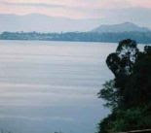 Lake Superior is a lake in Canada and the United States. The Ojibwe Native Americans call it Gitchigume. Lake Superior is in between Ontario and Minnesota to the north and Wisconsin and Michigan in the south, and is the largest of North America's Great Lakes. It is the world's third largest lake, and the world's largest freshwater lake (by area). Its outlet is the St. Marys River to Lake Huron. Over 80 species of fish live in Lake Superior. Great Lakes are a chain of freshwater lakes located in eastern North America, on the Canada – United States border. This group consists of Lakes Superior, Michigan, Huron, Erie, and Ontario, and they form the largest group of freshwater lakes on Earth.
What's the depth of Lake Superior? For some time reliable sources claimed 1332 feet. But more recently that figure has been revised to a little under 1300 ft. What explains the difference? Silting in of the deepest hole? More sophisticated measuring technology? Dunno. Yet this fact remains: Whether 1333 feet or 1295 feet deep, it contains more water than all of the other Great Lakes combined! And it accounts for 10% of the world's surface fresh water. This surface area (31,700 square miles) is greater than the combined acreage of the states of Vermont, Massachusetts, Rhode Island, Connecticut, and New Hampshire.
Lake Superior is the largest freshwater lake in the world, based on surface area, and the third largest in volume exceeded only by Lake Baikal in Siberia and Lake Tanganyika in Africa. There is enough water in Lake Superior to cover the entire land mass of North and South America with a foot of water!
The average underwater visibility of the Lake is 27 feet and in some parts of the lake it is 100 feet! Suffice to say it is the cleanest of the Great Lakes.
Water comes into Superior from over 300 streams and rivers and exits into Lake Huron via the St. Mary's River - which by the way 2000 years ago was more of a channel than a river because at one time the levels of Lake Huron and Lake Michigan were higher, much closer to the level of Superior than they are today. Unfortunately levels in Lake Superior have been falling recently with evaporation taking more out than the streams, rivers, and springs put in. An interesting fact you might not think would make a difference - warm winters where the lake doesn't freeze over also hurt the lake - because the open water allows higher evaporation. And as you'd expect lower levels of rainfall in the summer hurts too. Lower snowfall in some recent winters haven't helped either.
If you were able to walk the shoreline of Lake Superior, your trek would cover 2,726 miles. About 90% of that shoreline is forested and relatively uninhabited. Even though it is the largest freshwater lake in the world, you might be surprised to learn that the total population of All the cities, towns, villages, and settlements around the lake is less than 800,000 people. You largely escape the traffic you find in urban areas and get to enjoy the slower pace of small towns and villages that periodically dot the unspoiled shoreline around the lake.
The average annual water temperature is a chilly 40 degrees. Even though it is cold, the lake rarely completely freezes over. The huge volume of water acts as thermal mass moderating the cold of winter and the hot of summer. This mass also contributes to lake effect snowfalls, affecting primarily the Michigan Upper Peninsula and the Ontario eastern shore. But in the middle of summer there are sandy shallow water beaches where you can swim. (you can see some swimmers in photos on our Madeline Island Big Bay State Park page)
Lake Superior, Lake Michigan, Lake Huron, Lake Erie, and Lake Ontario, form the Great Lakes, straddling the United States and Canada to make up the largest group of freshwater lakes in the world. Collectively they contain 5,439 cubic miles of water (22,670 cubic km), or about 20% of all the earth’s fresh water, and cover an area of 94,250 square miles (244,106 square km).
Several other minor lakes and rivers are also included in the Great Lakes region including the Niagra River, Detroit River, St.
Lawrence River, St. Marys River, and the Georgian Bay. There are 35,000 islands estimated to be located on the Great Lakes, created by years of glacial activity.
Interestingly, Lake Michigan and Lake Huron are connected by the Straits of Mackinac, and can be technically considered a single lake.

LAKE BAIKAL
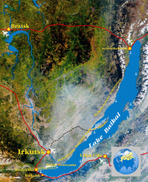
- Lake Baikal is often called the Pearl of the World, for its beauty, unique natural features, its flora and fauna.
- In 1996 UNESCO listed it as a World Heritage.
- Lake Baikal is the oldest lake in the world, which is 25-27 million years old.
Lake Baikal is the world’s deepest lake with a maximum depth of 1637 m. 336 rivers flow into Lake Baikal and the Angara River is the only river that flows out of it. The city of Irkutsk is located on its banks. From ancient times people have called Baikal Sacred Sea. Baikal is the cleanest natural fresh-water reservoir in the world, and the water clarity is down to 40 meters which also is the deepest water clarity of lakes in the world. Within Lake Baikal there are 2635 known species of animals and plants and 2/3 of those are endemic.
The landscapes around Lake Baikal are diverse. There are the mountains with the Siberian taiga forest, rocks of peculiar shapes, plains with different colours of wildflowers and sunny bays. Special microclimate exists on the islands of Baikal. There are places where one can see age-old trees, in arid places of Olkhon Island the flower edelweiss grows and in the area of Ushkanie Island one can experience a seal-rookery. Drawings of an ancient and primitive civilization can be seen at the marmoreal cliff Sagan-Zaba which is on the shore of the lake. According to scientists the drawings were made 4000 years ago (2000 years B.C.) in what is known as the Stone Age period. Drawings of the primitive men can also be seen in Sakyurte Mountain on the bank of Anga River flowing in the lake. There are many pagan holy places in the Baikal region. One can visit a rite of a Buryat Shaman (Buryat is a local population of Mongolian physical type), get acquainted with the culture and the way of life of Buryat people.
On the way from the city of Irkutsk to the village of Listvyanka (the nearest village located on the shores of Baikal) one will encount the Siberian village of Taltsi. At this village you will be able to visit an ethnographical museum which will introduce you to the history of the development of Siberia, its traditions, way of life. You will visit the wooden fortress, see implements and 300 year old buildings made of wood without nails. At both Taltsi and Listvyanka one will be able to buy traditional souvenirs and homecrafts that are specially made in Baikal region only.
There are about 3500 species of plants and animals in Lake Baikal and about 84% of them are endemics, which means that they can be found in Baikal only. According to the scientists’ research there are even more unknown species, as new varieties of organisms and plants are continuously developing in the lake.
Throughout its history both Baikal itself and the organisms inhabiting its world have undergone a complicated evolution. Because of this, the lake is inhabited both by very ancient varieties of organisms that originated in small lake pre-dating Baikal and younger ones that originated in Baikal itself.
The most famous endemic of the lake is a fresh-water seal, locally called “nerpa”. It has always been of great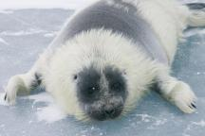 interest. Nerpa lives up to 55-60 years, while the average age of other seals from European lakes is only 30-35 years. It can stay under the water for about 70 minutes. One theory holds that the seal came into Baikal from the Arctic Ocean through the Lena River in prehistoric times, when it was part of an integral system with the lake. This theory finds support in the fact that chromasomic analyses and other data favor of the arctic-sea seal as its closest relation. However, there are many differences between the nerpas and related seals. The Baikal seals are more graceful, especially the females. They also differ from others by the silver- grey colour of their skin and have 2 more litres of blood, which enables them to do without fresh air for almost 70 minutes.
Baikal has more than 1000 species of aquatic flora! Besides the algae, about 20 species of flowering plants have been found here. The lake's bays and silty lagoons, its sheltered coves, and the river deltas harbour such plants as thin reed, water buckwheat, cattail, hornwort, and sedge. Golomyanka (oil fish). The most interesting of bullheads are these fishes! Golomyanka can be found nowhere else on the earth. It is unusually beautiful, sparkles blue and pink in sunshine. However, the sunshine causes it to melt! Only bones and a fat spot will be left there. It contains about 30% of oil, rich in vitamin A. There was a time when Tibetian monks came to Baikal and gathered golomyanka along the shores. Its fat was used as a remedy for many diseases. Native Siberians used it as the fuel for their lamps, and also medicinally. Old residents said that long time ago, after the storms, golomyankas were picked alongside the shores, the fat was melted and used in treatments for rheumatism, atherosclerosis and for healing wounds. It is noted that the golomyanka is very sensitive to the temperature of water. Its optimal temperature is up to +5°C, and it avoids higher temperatures. It cannot survive at +10 °C or higher. This fish is small in size, 15-20 cm long. It's designed to live in extreme pressures. Interesting are vertical migrations of Golomyanka from small depth to bottoms of very deep depressions, where even a cannon cannot shoot (because of the enormous pressure). Golomyanka moves up and down obeying the waves. During migrations the change of pressure leads to forced stops necessary for the adaptation to existing conditions. At night Golomyanka rises to the water surface, and at daytime it swims down to great depths. Each autumn the females, being viviparous instead of laying eggs, produce 2000-3000 of larvae and die afterwards.
Omul has been the symbol of Lake Baikal, in addition to bread that has been a symbol of Russia since time immemorial. The instinct of continuation of generation forces the omul to overcome turbulent rapids and river shoals. The caviar is left on the sandy and pebbly bottoms with moderate flows, and the development of its larvae lasts 6-7 months. For different reasons, a greater part of the caviar perishes: it is either buried under sand and silt or eaten up by predators. Omul lives 18-20 years. It is assumed that the ancestors of omul got into Baikal from the polar regions - Arctic ocean. One theory is that there was a time when a group of omul, going with the stream up Arctic rivers to spawn, came to Baikal and favoured these conditions for breeding and development. Probably the rout of infiltration of this fish drove on Yenisei and Angara rivers. The omul's colonization of Baikal and its adaptation to new living conditions appeared to be Nature's tremendous experiment, revealing flexibility and adaptability of aquatic organisms to changes of the environment. Omul biomass in Lake Baikal by data of the survey made on May 25 - June 5, 1999 = 26000 ton (300 000 000)
The Baikal shore is a unique ecological niche the inhabitants of which are connected with both dryland and water. Some of them live on land but feed in water, others spend the greater part of the time in water but breed and end their lifetime ashore. Due to its unique location, the land animals of the Baikal region contain specimens of the fauna found in Central Asia, Europe - Siberia and East Asia. Furthermore, the taiga near-lake backwoods are inhabited by rare animals which have become extinct in other places.
Among the upland high ridges, the mammals most widespread are mountain goat, snow sheep, Alpine field-vole, marmots, and in some places - lemmings. In summer on the slope and valley zones one can come across big ungulate animals and their predators, brown bear in particular.
Приложение № 4 пустые карточки для команд
Baikal |  | Superior
The Age
Length
The maximal width
The length of the coastline
The maximal depth
The total area
Number of flowing rivers

Baikal |  | Superior
The Age | 25 million years ago | 2 billion years ago
Length | 636 km | 563 km
The maximal width | 79,5 km | 257 km
The length of the coastline | 2000 km | 1600 km
The maximal depth | 1 642 m | 406 m
The total area | 31 500 | 244 106
Number of flowing rivers | 336 | 200

Приложение № 5 Материал по экологическим проблемам двух озер (Superior, Baikal)

Great Lakes Pollution and Invasive Species
Unfortunately, there have been concerns about the quality of water of the Great Lakes. Industrial waste and sewage were the primary culprits, specifically phosphorus, fertilizer, and toxic chemicals. In order to control this issue, the governments of Canada and the United States joined to sign the Great Lakes Water Quality Agreement in 1972. Such measures have drastically improved the quality of water, though pollution still finds it way into the waters, primarily through agricultural runoff.
Another major concern in the Great Lakes is non-native invasive species. An unanticipated introduction of such species can drastically alter evolved food chains and destroy local ecosystems.
The end result of this is a loss of biodiversity. Well known invasive species include the zebra mussel, Pacific salmon, carp, lamprey, and alewife.
1. Great lakes losing ice coverGreenhouse effect

Great Lakes are experiencing serious decline in ice cover due to warmer years. In the last 40 years Great Lakes lost 30 % of its ice cover, which is worrying information because according to National Oceanic and Atmospheric Administration this leaves Great Lakes open to evaporation and lower water levels.Results of their study showed that although the total amount of ice cover can vary substantially from year to year, the overall ice coverage on the world's largest system of freshwater lakes is diminishing, especially in the deepest, middle portions of Erie, Huron, Michigan, Ontario and Superior.

Other ecological problems in the Lakes and their surroundings have stemmed from urban sprawl, sewage disposal, and toxic industrial effluent. These, of course, also affect aquatic food chains and fish populations. Another aspect that caught popular attention was the “toxic blobs” (expanses of lake bed covered by various combinations of such substances as solvents, wood preservatives, coal tar, and metals) found in Lake Superior, the St. Clair River, and other portions of the Great Lakes region.

the development of ecological problems in the Great Lakes, it was the influx of parasitic lamprey populations after the development of the Erie Canal and the much later Welland Canal.

A third problem in the Great Lakes is a condition known as eutrophism. Large amounts of phosphorus, a plant nutrient, and nitrogen input in the lake result in a lake that is eutrophic (U.S. Army). These bodies of water are characterized by excessive algae growth. Algae in itself is not harmful, however the decay of algae causes oxygen deficiencies in the water which causes fish to die. Phosphorus exists in the soil as compounds of low solubility. When subjected to erosive waters the phosphorus compounds behave as soil particles and runoff (U.S. Army). Some major sources of phosphorous in Lake Waters is municipal waste water treatment plant discharge, point sources, and non-point sources like land and runoff waters (U.S. Army).

Ecological Crisis on Lake Baikal: What must we do to let the future generations as well as us know the taste of pure Baikal water?
- The first sign of the ecological crisis on Baikal was the rampant proliferation of the atypical filamentous Spirogyra alga. According to limnology scientists, the cause of the disaster was not global warming or other planetary-scale phenomena, but an excessive inflow of nutrients such as nitrogen and phosphorus into the lake. The studies revealed the culprit—the industrial and domestic wastewaters coming into the lake from ineffective or dilapidated wastewater treatment facilities located in coastal towns and the bilge and fecal waters from the numerous vessels.According to limnology scientists, the cause of this ecological disaster is not global warming or other planetary-scale phenomena, but pollution with wastewater that contains excess nutrients.

We need to work in several directions, and we are trying to do our best in these fields. One direction is to monitor what is happening to Lake Baikal. We cooperate with various scientific organizations, for example, this year we worked with the Department of Hydrobiology of the Moscow State University and with the Centre of Drinking Water. These research data will be publicly available. Another direction is the work with local residents. We need a social movement so that the community living on the coast of Lake Baikal could understand what is happening: the problem has been developing for more than ten years by now, and no one is doing anything, because no one understands anything. This year we paid special attention to this, we talked to people – the things they think about, the things they offer. Now people treat this in a peculiar way: “we do not understand anything about this, but we have the state, we have experts who must solve all this. New social relations should be built, so that people can communicate, cooperate, offer their solutions and implement them.
Приложение №6
Критерии оценивания
Конкурс 1.
- Название команды, девиз и приветствие полностью соответствуют тематике мероприятия – 3 балла
- Название команды, девиз и приветствие частично соответствуют тематике мероприятия – 2 балла
- Название команды, девиз и приветствие не соответствуют тематике мероприятия – 1 балл
Конкурс 2.
- Даны полные ответы на все вопросы – 3 балла
- Даны частичные ответы на все вопросы – 2 балла
- Даны частичные ответы на вопросы – 1 балл
- Ответы на вопросы не даны – 0 баллов
Конкурс 3.
- Презентация и доклад ведутся на английском языке, полностью раскрывая тему – 3 балла
- Презентация и доклад ведутся на английском языке, частично раскрывая тему – 2 балла
- Презентация и доклад ведутся на английском языке, переходя на русский язык и частично раскрывая тему – 1 балл
- Презентация и доклад ведутся на русском языке, не раскрывая тему.
Конкурс 4.
- Даны полные ответы, в соответствии с образцом – 3 балла
- Даны неполные ответы на все вопросы – 2 балла
- Даны частичные ответы на вопросы – 1 балл
- Ответы на вопросы не даны – 0 баллов
Конкурс 5
- Даны актуальные решения экологических проблем в полном размере – 3 балла
- Даны частично актуальные решения проблем – 2 балла
- Даны не актуальные решения проблем – 1 балл
- Не даны решения проблем – 0 баллов
Приложение №7 Презентация проекта
Рекомендуемая литература:
1. Копылова В.В. Методика проектной работы на уроках английского языка. – М.: Дрофа, 2006.
2. Палаева Л.И. Метод проектов в обучении иностранным языкам на среднем этапе общеобразовательной школы: Дис… к.п.н. – М., 2005.
3. Хуторской А.В. Технология проектирования ключевых и предметных компетенций. Инновации в общеобразовательной школе. Методы обучения. // Сб. научн.трудов / Под.ред. А.В. Хуторского. М., 2006.
4. Усачева И.В., Ильясов И.Ш. Методика поиска научной литературы, чтения и составления обзора по теме исследований. – М., 2011.
Используемые интернет-ресурсы:
- http://viperson.ru/articles/aktualnost-ekologicheskih-problem-narastaet
- Шумская Елена Михайловна, учитель английского языка Использование проектной технологии на уроках английского языка.http://festival.1september.ru/articles/514681/

